## **Dealing with more than 2 parameters**

What happens when we have more than 2 parameters

1. Consider the following dataset

|  |  |  |  |
| --- | --- | --- | --- |
| **ER_visits** | **Narcotics** | **Pain** | **TotalVisits** |
| 0 | 2 | 6 | 11 |
| 1 | 1 | 4 | 25 |
| 0 | 0 | 5 | 10 |
| 1 | 3 | 5 | 7 |

1. Then,
   1. Or z = (w1 * ER_visits) + (w2 * Narcotics) + (w3 * Pain) + (w4 * TotalVisits) + b
2. So the algorithm is as follows
   1. **Initialise:** w1, w2, w3, w4 and b randomly
   2. **Iterate over data**
      1. Compute ŷ
      2. Compute L(w,b)
      3. w1 = w1 - η𝚫w1
      4. w2 = w2 - η𝚫w2
      5. w3 = w3 - η𝚫w3
      6. w4 = w4 - η𝚫w4
      7. b = b + η𝚫b
      8. Where
   3. **Till satisfied**
      1. Number of epochs is reached ( ie 1000 passes/epochs)
      2. Continue till Loss < ε (some defined value)
      3. Continue till Loss(w,b)t+1 ≈ Loss(w,b)t
   4. A few of the functions from the code also change, namely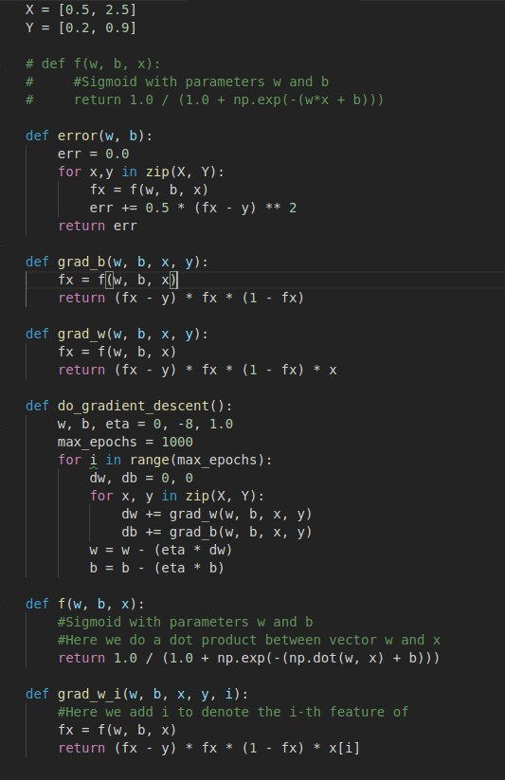
   5. The function do_grad_descent also changes, but we will figure it out in the practical implementation